**Electromagnetic pulse**

From Wikipedia, the free encyclopedia

*"Ebomb" redirects here. For EBOM, see Engineering bill of materials.*

The term **electromagnetic pulse** (sometimes abbreviated **EMP**) has the following meanings:

1. A burst of electromagnetic radiation that results from an explosion (especially a nuclear explosion) or a suddenly fluctuating magnetic field.  The resulting electric and magnetic fields may couple with electrical/electronic systems to produce damaging current and voltage surges.
2. A broadband, high-intensity, short-duration burst of electromagnetic energy.

In military terminology, an EMP bomb detonated hundreds of kilometers above the earth's surface is known as a **high-altitude electromagnetic pulse *('*HEMP**) device. Nuclear electromagnetic bombs have three distinct time components that result from different physical phenomena. Effects of an EMP device depend on the altitude of the detonation, energy yield, interactions with the earth's magnetic field, and shielding of targets.

**History**

The fact that an electromagnetic pulse is produced by a nuclear explosion was known since the earliest days of nuclear weapons testing, but the magnitude of the EMP and the significance of its effects were realized very slowly.

During the first United States nuclear test in 1945, electronic equipment was shielded due to Enrico Fermi's expectation of an electromagnetic pulse from the detonation. The official technical history for that first nuclear test states, "All signal lines were completely shielded, in many cases doubly shielded. In spite of this many records were lost because of spurious pickup at the time of the explosion that paralyzed the recording equipment."  During British nuclear testing in 1952–1953 there were instrumentation failures that were attributed to "radioflash," which was then the British term for EMP.

The high altitude nuclear tests of 1962, as described below, increased awareness of EMP beyond the original small population of nuclear weapons scientists and engineers. The larger scientific community became aware of the significance of the EMP problem after a series of three articles were published about nuclear electromagnetic pulse in 1981 by William J. Broad in the weekly publication *Science*.

**Starfish Prime**

Main article: Starfish Prime

In July 1962, a 1.44 megaton (6.0 PJ) United States nuclear test in space, 400 kilometres (250 mi) above the mid-Pacific Ocean, called the Starfish Prime test, demonstrated to nuclear scientists that the magnitude and effects of a high altitude nuclear explosion were much larger than had been previously calculated. Starfish Prime also made those effects known to the public by causing electrical damage in Hawaii, about 1,445 kilometres (898 mi) away from the detonation point, knocking out about 300 streetlights, setting off numerous burglar alarms and damaging a telephone company microwave link.

The EMP damage of the Starfish Prime test was quickly repaired because of the ruggedness (compared to today) of the electrical and electronic infrastructure of Hawaii in 1962. Realization of the potential impacts of EMP became more apparent to some scientists and engineers during the 1970s as more sensitive solid-state electronics began to come into widespread use.

The relatively small magnitude of the Starfish Prime EMP in Hawaii (about 5,600 volts/meter) and the relatively small amount of damage done (for example, only 1 to 3 percent of streetlights extinguished) led some scientists to believe, in the early days of EMP research, that the problem might not be as significant as was later realized. Newer calculations showed that if the Starfish Prime warhead had been detonated over the northern continental United States, the magnitude of the EMP would have been much larger (22,000 to 30,000 volts/meter) because of the greater strength of the Earth's magnetic field over the United States, as well as the different orientation of the Earth's magnetic field at high latitudes. These new calculations, combined with the accelerating reliance on EMP-sensitive microelectronics, heightened awareness that the EMP threat could be a very significant problem.

**Soviet Test 184**

Main article: The K Project

In 1962, the Soviet Union also performed a series of three EMP-producing nuclear tests in space over Kazakhstan, which were the last in the series called "The K Project".[10]  Although these weapons were much smaller (300 kilotons or 1.3 PJ) than the Starfish Prime test, since those tests were done over a populated large land mass (and also at a location where the Earth's magnetic field was greater), the damage caused by the resulting EMP was reportedly much greater than in the Starfish Prime nuclear test. The geomagnetic storm-like E3 pulse (from the test designated as "Test 184") even induced an electrical current surge in a long underground power line that caused a fire in the power plant in the city of Karaganda. After the collapse of the Soviet Union, the level of this damage was communicated informally to scientists in the United States.  Formal documentation of some of the EMP damage in Kazakhstan exists but is still sparse in the open scientific literature.

**Non-nuclear history**

The concept of the explosively pumped flux compression generator for generating a non-nuclear electromagnetic pulse was conceived as early as 1951 by Andrei Sakharov in the Soviet Union, but nations have usually kept their most recent work on non-nuclear EMP highly classified until the technology was old enough for similar ideas to be conceived by physicists in other nations.

According to some reports, the U.S. Navy used experimental non-nuclear E-bombs during the 1991 Gulf War. These bombs utilized warheads that converted the energy of conventional explosives into a pulse of radio energy.[15] CBS News also reported that the U.S. dropped an E-bomb on Iraqi TV during the 2003 invasion of Iraq, but this has not been confirmed.

**Characteristics of nuclear EMP**

The case of a **nuclear electromagnetic pulse** differs from other kinds of electromagnetic pulse (EMP) in being a complex electromagnetic multi-pulse. The complex multi-pulse is usually described in terms of three components, and these three components have been defined as such by the international standards commission called the International Electrotechnical Commission (IEC).

The three components of nuclear EMP, as defined by the IEC, are called **E1**, **E2** and **E3**.

The **E1** pulse is the very fast component of nuclear EMP. The **E1** component has an intense electric field that can quickly induce very high voltages in electrical conductors. **E1** is the component that can destroy computers and communications equipment and is too fast for ordinary lightning protectors.

The **E1** component is produced when gamma radiation from the nuclear detonation knocks electrons out of the atoms in the upper atmosphere. The electrons travel in a generally downward direction at relativistic speeds (more than 90 percent of the speed of light). This essentially produces a large pulse of electrical current vertically in the upper atmosphere over the entire affected area. This electrical current is acted upon by the Earth's magnetic field to produce a very large, but very brief, electromagnetic pulse over the affected area.

The **E2** component of the pulse has many similarities to the electromagnetic pulses produced by lightning. Because of the similarities to lightning-caused pulses and the widespread use of lightning protection technology, the **E2** pulse is generally considered to be the easiest to protect against.

The **E3** component of the pulse is a very slow pulse, lasting tens to hundreds of seconds, that is caused by the nuclear detonation heaving the Earth's magnetic field out of the way, followed by the restoration of the magnetic field to its natural place. The **E3** component has similarities to a geomagnetic storm caused by a very severe solar flare. Like a geomagnetic storm, **E3** can produce geomagnetically induced currents in long electrical conductors, which can then damage components such as power line transformers.

For a more thorough description of **E3** damage mechanisms, see the main article:  Geomagnetically induced current

**Practical considerations for nuclear EMP**

The strongest part of the pulse lasts for only a fraction of a second, but any unprotected electrical equipment — and anything connected to electrical cables, which act as giant lightning rods or antennas — will be affected by the pulse. Older, vacuum tube (valve) based equipment is much less vulnerable to EMP than newer solid state equipment; Soviet Cold War–era military aircraft often had avionics based on vacuum tubes due both to limitations in Soviet solid-state capabilities and a belief that the vacuum gear would survive better.

Although vacuum tubes are far more resistant to EMP than solid state devices, other components in vacuum tube circuitry can be damaged by EMP. Vacuum tube equipment actually was damaged in 1962 nuclear EMP testing.  Also, the solid state PRC-77 VHF manpack radio survived extensive EMP testing. The earlier PRC-25, nearly identical except for a vacuum tube final amplification stage, had been tested in EMP simulators but was not certified to remain fully functional.

Many nuclear detonations have taken place using bombs dropped by aircraft. The B-29 aircraft that delivered the atomic weapons at Hiroshima and Nagasaki did not lose power due to damage to their electrical or electronic systems. This is simply because electrons (ejected from the air by gamma rays) are stopped quickly in normal air for bursts below roughly 10 km (about 6 miles), so they do not get a chance to be significantly deflected by the Earth's magnetic field (since the deflection causes the powerful EMP seen in high altitude bursts). This fact does point out the limited use of smaller burst altitudes for widespread EMP.

If the aircraft carrying the Hiroshima and Nagasaki bombs had been within the intense nuclear radiation zone when the bombs exploded over those cities, then they would have suffered effects from the charge separation (radial) EMP. But this only occurs within the severe blast radius for detonations below about 10 km altitude.

During nuclear tests in 1962, EMP disruptions were suffered aboard KC-135 photographic aircraft flying 300 km (190 mi) from the 410 kt (1,700 TJ) *Bluegill* and 410 kt (1,700 TJ) *Kingfish* detonations (48 and 95 km (30 and 59 mi) burst altitude, respectively) but the vital aircraft electronics were far less sophisticated than today and the aircraft were able to land safely.

**Generation of nuclear EMP**

Several major factors control the effectiveness of a nuclear EMP weapon. These are:

1. The altitude of the weapon when detonated;
2. The yield and construction details of the weapon;
3. The distance from the weapon when detonated;
4. Geographical depth or intervening geographical features;
5. The local strength of the Earth's magnetic field.

Beyond a certain altitude a nuclear weapon will not produce any EMP, as the gamma rays will have had sufficient distance to disperse. In deep space or on worlds with no magnetic field (the moon or Mars for example) there will be little or no EMP. This has implications for certain kinds of nuclear rocket engines, such as Project Orion.

[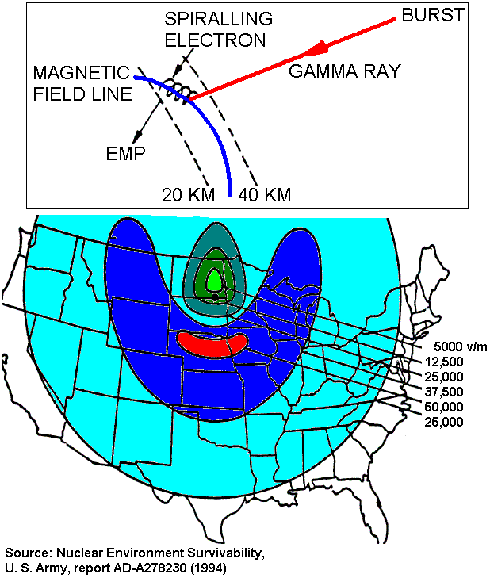](http://en.wikipedia.org/wiki/File:EMP_mechanism.GIF)

**Weapon altitude**

The mechanism for a 400 km high altitude burst EMP: gamma rays hit the atmosphere between 20–40 km altitude, ejecting electrons which are then deflected sideways by the Earth's magnetic field. This makes the electrons radiate EMP over a massive area. Because of the curvature and downward tilt of Earth's magnetic field over the USA, the maximum EMP occurs south of the detonation and the minimum occurs to the north.

[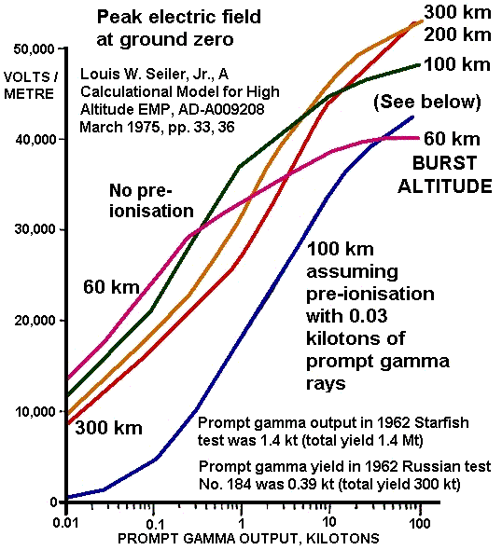](http://en.wikipedia.org/wiki/File:High_altitude_EMP2.GIF)

How the peak EMP on the ground varies with the weapon yield and burst altitude. The yield here is the prompt gamma ray output measured in kilotons. This varies from 0.115–0.5% of the total weapon yield, depending on weapon design. The 1.4 Mt total yield 1962 Starfish Prime test had a gamma output of 0.1%, hence 1.4 kt of prompt gamma rays. (The **blue** 'pre-ionisation' curve applies to certain types of thermonuclear weapon, where gamma and x-rays from the primary fission stage ionise the atmosphere and make it electrically conductive before the main pulse from the thermonuclear stage. The pre-ionisation in some situations can literally short out part of the final EMP, by allowing a conduction current to immediately oppose the Compton current of electrons.)

How the area affected depends on the burst altitude.

According to an internet primer published by the Federation of American Scientists

[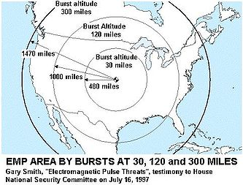](http://en.wikipedia.org/wiki/File:EMP_areas.JPG)

*A high-altitude nuclear detonation produces an immediate flux of gamma rays from the nuclear reactions within the device. These photons in turn produce high energy free electrons by Compton scattering at altitudes between (roughly) 20 and 40 km. These electrons are then trapped in the Earth's magnetic field, giving rise to an oscillating electric current. This current is asymmetric in general and gives rise to a rapidly rising radiated electromagnetic field called an electromagnetic pulse (EMP). Because the electrons are trapped essentially simultaneously, a very large electromagnetic source radiates coherently.*

*The pulse can easily span continent-sized areas, and this radiation can affect systems on land, sea, and air. The first recorded EMP incident accompanied a high-altitude nuclear test over the South Pacific and resulted in power system failures as far away as Hawaii. A large device detonated at 400–500 km (250 to 312 miles) over Kansas would affect all of the continental U.S. The signal from such an event extends to the visual horizon as seen from the burst point.*

Thus, for equipment to be affected, the weapon needs to be above the visual horizon. Because of the nature of the pulse as a large, long, high powered, noisy spike, it is doubtful that there would be much protection if the explosion were seen in the sky just below the tops of hills or mountains.

The altitude indicated above is greater than that of the International Space Station and many low Earth orbit satellites. Large weapons could have a dramatic impact on satellite operations and communications; smaller weapons have less such potential.

**Weapon yield**

Typical nuclear weapon yields used during Cold War planning for EMP attacks were in the range of 1 to 10 megatons (4.2 to 42 PJ) This is roughly 50 to 500 times the sizes of the weapons the United States used in Japan at Hiroshima and Nagasaki. Physicists have testified at United States Congressional hearings, however, that weapons with yields of 10 kilotons (42 TJ) or less can produce a very large EMP.

The EMP at a fixed distance from a nuclear weapon does not depend directly on the yield but at most only increases as the square root of the yield (see the illustration to the right).  This means that although a 10 kiloton weapon has only 0.7% of the total energy release of the 1.44-megaton Starfish Prime test, the EMP will be at least 8% as powerful. Since the E1 component of nuclear EMP depends on the prompt gamma ray output, which was only 0.1% of yield in Starfish Prime but can be 0.5% of yield in pure fission weapons of low yield, a 10 kiloton bomb can easily be 5 x 8% = 40% as powerful as the 1.44 megaton Starfish Prime at producing EMP.

The total prompt gamma ray energy in a fission explosion is 3.5% of the yield, but in a 10 kiloton detonation the high explosive around the bomb core absorbs about 85% of the prompt gamma rays, so the output is only about 0.5% of the yield in kilotons. In the thermonuclear Starfish Prime the fission yield was less than 100% to begin with, and then the thicker outer casing absorbed about 95% of the prompt gamma rays from the pusher around the fusion stage. Thermonuclear weapons are also less efficient at producing EMP because the first stage can pre-ionize the air which becomes conductive and hence rapidly shorts out the electron Compton currents generated by the final, larger yield thermonuclear stage. Hence, small pure fission weapons with thin cases are far more efficient at causing EMP than most megaton bombs.

This analysis, however, only applies to the fast E1 and E2 components of nuclear EMP. The geomagnetic storm-like E3 component of nuclear EMP is more closely proportional to the total energy yield of the weapon.

**Weapon distance**

A unique and important aspect of **nuclear** EMP is that all of the components of the electromagnetic pulse are generated **outside** of the weapon. The important E1 component is generated by interaction with the electrons in the upper atmosphere that are hit by gamma radiation from the weapon — and the subsequent effects upon those electrons by the Earth's magnetic field.

For high-altitude nuclear explosions, this means that much of the EMP is actually generated at a large distance from the detonation (where the gamma radiation from the explosion hits the upper atmosphere). This causes the electric field from the EMP to be remarkably uniform over the large area affected.

According to the standard reference text on nuclear weapons effects published by the U.S. Department of Defense, "The peak electric field (and its amplitude) at the Earth's surface from a high-altitude burst will depend upon the explosion yield, the height of the burst, the location of the observer, and the orientation with respect to the geomagnetic field.  As a general rule, however, the field strength may be expected to be tens of kilovolts per meter over most of the area receiving the EMP radiation."

The same reference book also states that, "... over most of the area affected by the EMP the electric field strength on the ground would exceed 0.5*E*max.   For yields of less than a few hundred kilotons, this would not necessarily be true because the field strength at the Earth's tangent could be substantially less than 0.5*E*max."

(*E*max refers to the maximum electric field strength in the affected area.)

In other words, the electric field strength in the entire area that is affected by the EMP will be fairly uniform for weapons with a large gamma ray output; but for much smaller weapons, the electric field may fall off at a comparatively faster rate at large distances from the detonation point.

It is the **peak electric field** of the EMP that determines the **peak voltage** induced in equipment and other electrical conductors on the ground, and most of the damage is determined by induced voltages.

For nuclear detonations within the atmosphere, the situation is more complex. Within the range of gamma ray deposition, simple laws no longer hold as the air is ionized and there are other EMP effects, such as a radial electric field due to the separation of Compton electrons from air molecules, together with other complex phenomena. For a surface burst, absorption of gamma rays by air would limit the range of gamma ray deposition to approximately 10 miles, while for a burst in the lower-density air at high altitudes, the range of deposition would be far greater.

**Non-nuclear electromagnetic pulse**

**Non-nuclear electromagnetic pulse** (**NNEMP**) is an electromagnetic pulse generated without use of nuclear weapons. There are a number of devices that can achieve this objective, ranging from a large low-inductance capacitor bank discharged into a single-loop antenna or a microwave generator to an explosively pumped flux compression generator. To achieve the frequency characteristics of the pulse needed for optimal coupling into the target, wave-shaping circuits and/or microwave generators are added between the pulse source and the antenna. A vacuum tube particularly suitable for microwave conversion of high energy pulses is the vircator.

NNEMP generators can be carried as a payload of bombs and cruise missiles, allowing construction of electromagnetic bombs with diminished mechanical, thermal and ionizing radiation effects and without the political consequences of deploying nuclear weapons.

The range of NNEMP weapons (non-nuclear electromagnetic bombs) is severely limited compared to nuclear EMP. This is because nearly all NNEMP devices used as weapons require chemical explosives as their initial energy source, but nuclear explosives have an energy yield on the order of one million times that of chemical explosives of similar weight.  In addition to the large difference in the energy density of the initial energy source, the electromagnetic pulse from NNEMP weapons must come from within the weapon itself, while nuclear weapons generate EMP as a secondary effect, often at great distances from the detonation.  These facts severely limit the range of NNEMP weapons as compared to their nuclear counterparts, but allow for more surgical target discrimination. The effect of small e-bombs has proven to be sufficient for certain terrorist or military operations. Examples of such operations include the destruction of certain fragile electronic control systems of the type critical to the operation of many ground vehicles and aircraft.

[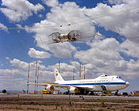](http://en.wikipedia.org/wiki/File:E-4_advanced_airborne_command_post_EMP_sim.jpg)

A right front view of a Boeing E-4 advanced airborne command post (AABNCP) on the electromagnetic pulse (EMP) simulator (HAGII-C) for testing.

[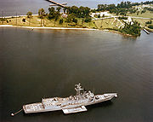](http://en.wikipedia.org/wiki/File:USS_Estocin_FFG-15_moored_near_EMPRESS_I.jpg)

USS *Estocin* (FFG-15) moored near the Electro Magnetic Pulse Radiation Environmental Simulator for Ships I (EMPRESS I) facility (antennae at top of image).

NNEMP generators also include large structures built to generate EMP for testing of electronics to determine how well it survives EMP. In addition, the use of ultra-wideband radars can generate EMP in areas immediately adjacent to the radar; this phenomenon is only partly understood.

Information about the EMP simulators used by the United States during the latter part of the Cold War, along with more general information about electromagnetic pulse, are now in papers under the care of the SUMMA Foundation, which is now hosted at the University of New Mexico.

The SUMMA Foundation web site includes documentation about the huge wooden Trestle simulator in New Mexico, which was the world's largest EMP simulator.  Nearly all of these large EMP simulators used a specialized version of a Marx generator.  The SUMMA Foundation now has a 44-minute documentary movie on its web site called "TRESTLE: Landmark of the Cold War"

Many large EMP simulators were also built in the Soviet Union, as well as in the United Kingdom, France, Germany, The Netherlands, Switzerland and Italy.

**Post-Cold War attack scenarios**

Typical modern scenarios seen in large numbers of news accounts and opinion articles speculate about the use of nuclear weapons by rogue states or terrorists in an EMP attack. Details of such scenarios are always controversial. It is impossible to know what kind of capabilities such terrorists might acquire, especially if they are aided by state sponsors with access to advanced technology.

Some rogue states have developed an ability to deliver a light missile payload to the necessary altitude for an EMP attack. Nuclear weapons in general have a much heavier missile payload, however advanced weapons design enables larger weapon yields with lighter weight. It is difficult to know if any particular rogue state has the necessary combination of advanced missile technology and nuclear weapons technology to perform an effective nuclear EMP attack over an industrialized country.

A common scenario is the detonation of a device over the middle of the U.S. using long-range missiles that have historically been available only to major military powers. An offshore detonation at high altitude, by contrast, would present less technical difficulty and would disrupt both an entire coast and regions hundreds of miles inland (*e.g.* 120 mile altitude, 1,000 mile EMP radius).

The United States military services have developed, and in some cases have published, hypothetical EMP attack scenarios that are likely to be much more technically accurate than those that appear in the popular press.

In 2009, Yael Shahar, a director of the International Institute for Counter-Terrorism, reported that home-built handheld non-nuclear e-bombs may become a significant threat to airliners.

**United States EMP vulnerability studies**

The United States EMP Commission was authorized by the United States Congress in Fiscal Year 2001, and re-authorized in Fiscal Year 2006. The commission is formally known as the **Commission to Assess the Threat to the United States from Electromagnetic Pulse (EMP) Attack**.

The United States EMP Commission has brought together a group of notable scientists and technologists to compile several reports. In 2008, the EMP Commission released the **Critical National Infrastructures Report**. This report describes, in as much detail as practical, the likely consequences of a nuclear EMP on civilian infrastructures. Although this report was directed specifically toward the United States, most of the information can obviously be generalized to the civilian infrastructure of other industrialized countries.

The 2008 report was a followup to a more generalized report issued by the commission in 2004.

In written testimony delivered to the United States Senate in 2005, an EMP Commission staff member reported:

*The EMP Commission sponsored a worldwide survey of foreign scientific and military literature to evaluate the knowledge, and possibly the intentions, of foreign states with respect to electromagnetic pulse (EMP) attack. The survey found that the physics of EMP phenomenon and the military potential of EMP attack are widely understood in the international community, as reflected in official and unofficial writings and statements. The survey of open sources over the past decade finds that knowledge about EMP and EMP attack is evidenced in at least Britain, France, Germany, Israel, Egypt, Taiwan, Sweden, Cuba, India, Pakistan, Iraq under Saddam Hussein, Iran, North Korea, China and Russia.*

. . .

*Many foreign analysts–particularly in Iran, North Korea, China, and Russia–view the United States as a potential aggressor that would be willing to use its entire panoply of weapons, including nuclear weapons, in a first strike. They perceive the United States as having contingency plans to make a nuclear EMP attack, and as being willing to execute those plans under a broad range of circumstances.*

*Russian and Chinese military scientists in open source writings describe the basic principles of nuclear weapons designed specifically to generate an enhanced-EMP effect, that they term "Super-EMP" weapons. "Super-EMP" weapons, according to these foreign open source writings, can destroy even the best protected U.S. military and civilian electronic systems.*

Prior to the creation of the United States EMP Commission, a widely-read article by engineer and defense analyst Carlo Kopp, first published in 1996, stated that suitable materials and tools to create basic non-nuclear electromagnetic weapons are commonly available. In that article, Kopp said, "The threat of electromagnetic bomb proliferation is very real." Although Kopp's article mentions nuclear EMP, the article was mostly about non-nuclear EMP weapons.

**Clarification of common misconceptions**

In non-technical writings about nuclear EMP, both in print and on the Internet, some common misconceptions about EMP are nearly always found. These widely-repeated misconceptions have led to a very considerable amount of confusion about the subject. Here are some further clarifications on common areas of confusion that have already been discussed (with references) in the above sections of this article:

1. Most nuclear weapons effects vary greatly depending upon the altitude of the detonation. This is especially true of nuclear EMP. The standard reference text on nuclear weapon effects published by the U.S. Department of Defense discusses this relationship extensively in the first two chapters, and provides mutually-exclusive definitions for phrases such as "air burst" and "high-altitude burst." As explained in above sections of this article, nuclear detonations at all altitudes within the Earth's magnetic field will produce an electromagnetic pulse; but the magnitude of the EMP and area that is affected by the EMP are strongly affected by many factors, and is especially strongly dependent upon the altitude of the detonation. (See the discussion above in the "Weapon altitude" and "Weapon distance" sections.)  A nuclear explosion in deep space and not in a strong planetary magnetic field would be ineffective at generating EMP.
2. EMP is not a new kind of weapon effect. As stated in the "History" section above, nuclear EMP from a nuclear air burst has been known since 1945. The unique characteristics of high-altitude nuclear EMP have been known since at least 1962. Non-nuclear EMP has been known since at least 1951. Electromagnetic pulse is a prompt *secondary* effect of a nuclear explosion, and nearly all of the nuclear EMP is produced outside of the weapon.  (*All* nuclear weapons can produce EMP as a secondary effect, but the effect can be enhanced by special weapon design.)
3. The E3 component of nuclear EMP that produces geomagnetically induced currents in very long electrical conductors is roughly proportional to the total energy yield of the weapon. The other components of nuclear EMP are less likely to be dependent on total energy yield of the weapon. The E1 component, in particular, is proportional to prompt gamma ray output; but EMP levels can be strongly affected if more than one burst of gamma rays occurs in a short time period. Large thermonuclear weapons produce large energy yields through a multi-stage process. This multi-stage process is completed within a small fraction of a second, but it nevertheless requires a finite length of time. The first fission reaction is usually of relatively small yield, and the gamma rays produced by the first stage pre-ionize atmospheric molecules in the stratosphere. This pre-ionization causes the gamma ray emission from the high-energy final stage of the thermonuclear weapon (a fraction of a second later) to be relatively ineffective at producing a large *E1* pulse. (See the blue pre-ionization curve in the "Peak Electric Field at Ground Zero" graph above.)
4. It has long been known that there are many ways to protect against nuclear EMP (or to quickly begin repairs where protection is not practical); but the United States EMP Commission determined that such protections are almost completely absent in the civilian infrastructure of the United States, and that even large sectors of the United States military services were no longer protected against EMP to the level that they were during the Cold War. The public statements of the physicists and engineers working in the EMP field tend to emphasize the importance of making electronic equipment and electrical components resistant to EMP — and of keeping adequate spare parts on hand, and in the proper location, to enable prompt repairs to be made. The United States EMP Commission did not look at the civilian infrastructures of other nations.